Troubleshooting Guide



**Troubleshoot Active Directory Related Issues**

Contents

1. Primary SMTP address Change/Name Change/Aliases Requests 3

2. Multi-Factor Authentication Exclusion 3

3. Email address not recognized in outlook/Incorrect Contact card 3

4. EWS (Exchange web services) Inaccessible 6

5. User's Office disablement due to non-compliance 8

6. Access/backup required of former employee’s mailbox 8

7. Increase Mailbox quota request/Online archive Enablement 9

# Primary SMTP address Change/Name Change/Aliases Requests

User is requesting change in primary SMTP address for the following sample reason:

Ex: User wants to have different/additional email address in Outlook contact card

By default, email addresses are stamped or Mapped by the accenture ID i.e. “@accenture.com” for all the accenture domain users in case the mapping is required with any another existing Accenture accepted domain such requests are taken care by the IAM team (SNOW Queue Name: INFRADELV-IAM-IGA-OPER) they will update the requested IP domain mail mask, this is out of M&C scope.

Requests can be raised here, <https://directory.accenture.com>

# Multi-Factor Authentication Exclusion

All requests for MFA exclusion should be forwarded to IAM team

The service will be supported only via service request (RITM) module

User needs to refer the [link](https://people.accenture.com/stream/eventid/36386237) complete the “Symantec VIP Exclusion” and submit it to the IAM team.

(**SNOW Queue Name: INFRADELV-IAM-IGA-OPER**).

# Email address not recognized in outlook/Incorrect Contact card

When user is unable to find the updated email address, user information (name change, phone no, location etc.) and group information (newly added members) in outlook.

1. Check if user can reproduce the issue in OWA, if yes follow the steps below, if no go to step 4 (when issue is reproducible in outlook only).
2. Check for the user’s MS Teams
   1. Check for the user’s Contact Card

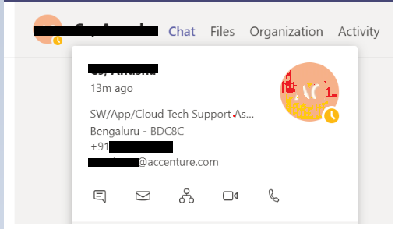

* 1. Check if all the user’s information is correct. If not, compare the user’s information on Outlook’s Address Book

1. Check Outlook’s Address Book
2. Open Outlook and search for Address Book.
3. Search for user’s name on the Address Book and double click the user’s name.

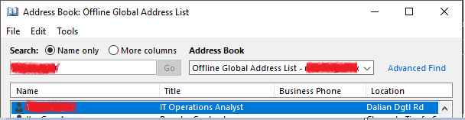

1. Once you open the user’s Address Book, check if all the user’s information are correct.

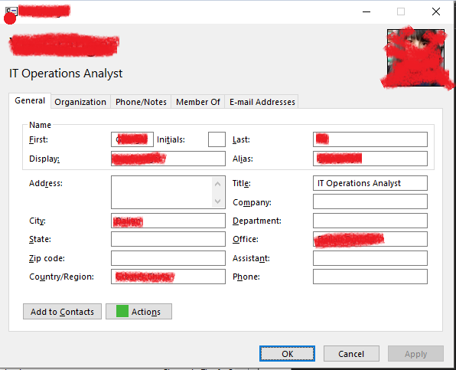

Open <https://people.accenture.com> and search for the user’s name and check for his/her contact information. It is possible that his/her account in <https://people.accenture.com> didn’t sync on user’s Contact Card and Address Book.

If there are wrong information on the user’s Contact Card and Address Book, kindly seek assistance from IAM Team (**INFRADELV-IAM-IGA-OPER**) to check the user’s account and do the necessary actions.

1. If the issue persists in outlook alone, Update the Address Book in outlook.

Outlook->File->Info->Account Settings->Download Address Book

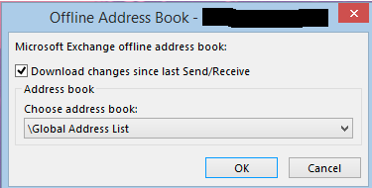

1. If the issue occurs after the Address book update, try to download it from the scratch.
2. Remove the files from the folder

C:\Users\<user id>\AppData\Local\Microsoft\Outlook\Offline Address Books

1. Go to Download Address Book. Unselect the check box ‘Download changes since last Send/Receive’ and click OK.
2. Once the address book is updated close the outlook re-open and see if the issue is reproducible.
3. If the above steps are not fixing the issue, raise an incident with M&C team (**SNOW group MSGCOLLAB-O365-OPER**).

# EWS (Exchange web services) Inaccessible

Exchange Web Services (EWS) provides the functionality to enable client applications to communicate with the Exchange server. EWS provides access to much of the same data that is made available through Microsoft Office Outlook. EWS clients can integrate Outlook data into Line-of-Business (LOB) applications.

**Below mentioned tests required MFA excluded User ID’s. if it’s not enabled please refer the process mentioned at Point Number 2**

1. **The EWS URL is** <https://myemail.accenture.com/EWS/Exchange.asmx>

Once the URL is clicked provide the userID (complete email ID ex. *John.doe@accenture.com*) and password,

You should get a response like below which implies that the URL is working with the said credentials

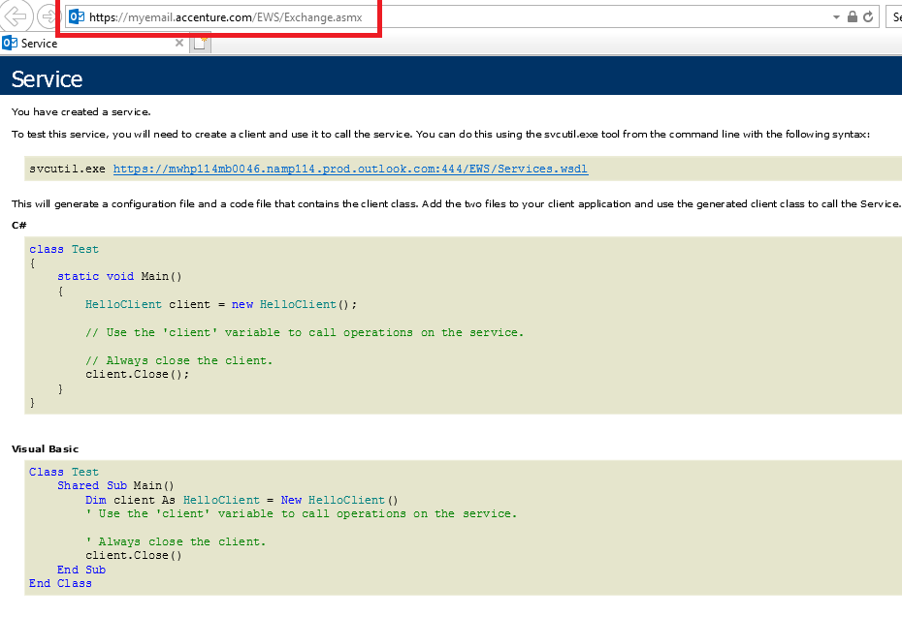

In addition, the steps below can be performed to rule out any issues if related to proxy

1. EWS inaccessible is usually encountered when an incorrect WinHTTP Proxy is configured:

Steps to fix the issue:

Open an elevated command prompt:

1. Press the Start key or click the Start button.
2. Type Command Prompt
3. Right-click Command Prompt and then click Run as Administrator
4. If you are prompted for an administrator password or for confirmation, enter password or click Allow

Steps to fix the issue are depending the versions of Windows and Office

1. **If the user is running with the below versions:**

A 32-bit version of Office on a 32-bit version of Windows, or  
A 64-bit version of Office on a 64-bit version of Windows

* 1. At the cmd prompt, type the command then press ENTER: **netsh winhttp show proxy**

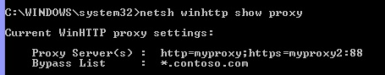

* 1. The current WinHTTP proxy settings will be displayed and if the Proxy Servers shown is incorrect, remove it by using the command: **netsh winhttp reset proxy**

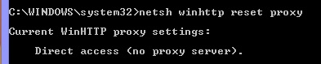

# 5. User's Office disablement due to non-compliance

Users will not able to access any of the office application due to system Non-compliance. SD should check the users details in User Audit(<https://directory.accenture.com/useraudit/>) and if they find that user ID is disabled due to Security Flag

Screenshot given below:

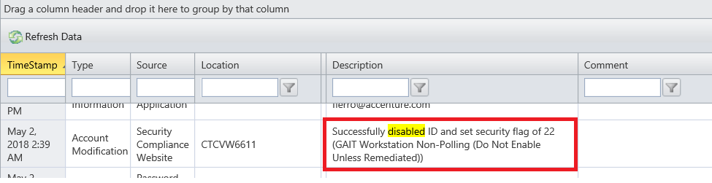

Service Desk should reach out to GAIT team ([**SNOW**](mailto:Global.Asset.Integrity.Team@accenture.com) **group WKSTNSVS-ASSET-MGMT**). Once the approval is provided by GAIT Team. SD can enable user ID.

Note: SD can inform the user to reach out local workstation support to run PC checkup tool on user’s PC and to assist in fixing the non-compliant issues after running the tool.

# 6.Access/backup required of former employee’s mailbox

User requests to get backup of old ID (Example -Former employee ‘s manager wants some client emails etc) and since the user is former employee his mailbox needs to be enabled for taking backup. For these cases we need to check when was the ID disabled. You can check the same is user Audit.

<https://directory.accenture.com/useraudit/>.



This is dealt with the IAM and the CIRT team, once the Employee resigns/retires the mailbox will be in inactive state for 30 days from the day of disablement, Exchange Online retains mailboxes for a brief period of 30 days after they have been deleted. If access is required on critical basis the same may be provided to the requestor with the details shared depending on the necessary approval from the CIRT team (by sending email to [CIRT@accenture.com](mailto:CIRT@accenture.com), and in the email, provide the incident ticket number, mailbox involved and the business case and ask for approval to obtained the backup of the involved mailbox), the email approval from CIRT then should be attached to the incident ticket then and the case should assigned to IAM team (**SNOW queue: INFRADELV-IAM-IGA-OPER**) afterwards.

# Increase Mailbox quota request/Online archive Enablement

User’s/ shared mailbox is full and he or she is requesting for temporary quota increase. User can apply the **ONLINE ARCHIVE** solution for **user mailbox only**

Below applies for user mailbox:

1. You can ask user to clean up the mailbox of old unwanted emails.
2. You can educate the user for online archiving and if user is ready for online archive. You can refer to the link below so that user can enable online archive policies on their own:

<https://in.accenture.com/mycomputer/using-the-auto-archive-feature/>

1. For user mailbox, verify if the mailbox is enabled for Online Archive in [UserStatus](https://directory.accenture.com/UserStatus/) Portal.

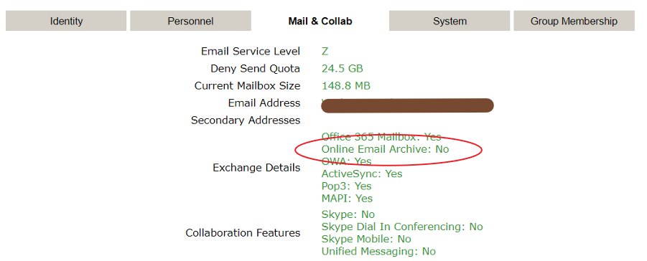

If enabled (Yes), follow the below steps, otherwise reach out to IAM team to enable the online archive (IAM team **SNOW group INFRADELV-IAM-IGA-OPER**).

1. To open your mail retention policies, log into myemail.accenture.com in Internet Explorer.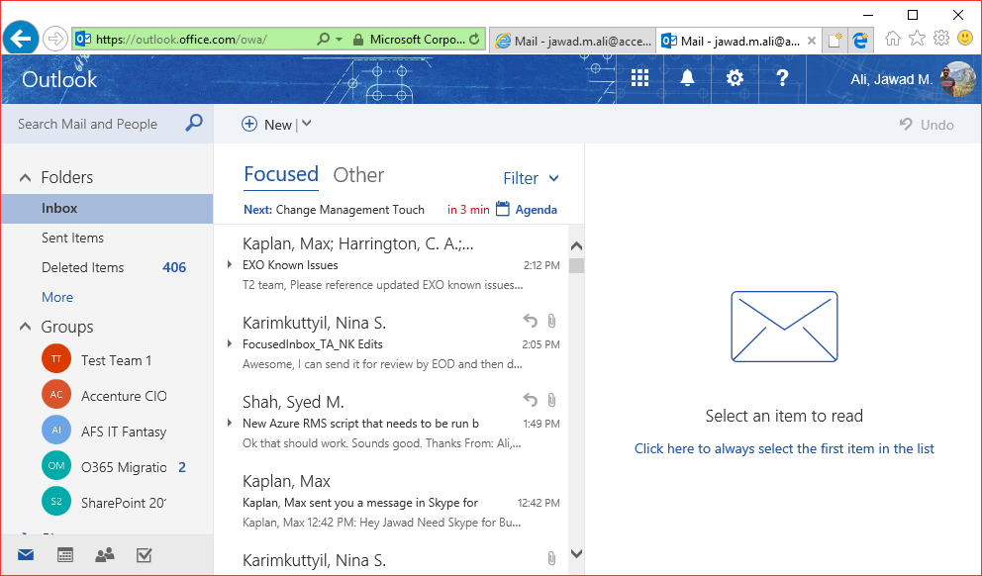
2. Select the Gear in the top-right corner and then select **Options**. You can also select **Mail** under **Your app settings**.

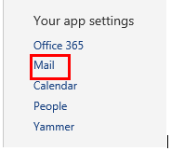

1. Then select **Retention** **policies** under **Automatic** Processing under **Mail.** To add a policy, select the **+** symbol.

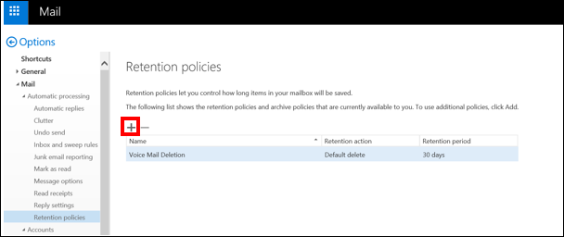

1. Here you will be able to add or remove policies that are available to you. Select the policies you’d like to add and then select **Add** and then click **Save**.

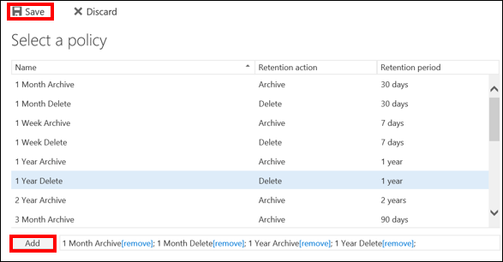

1. You will now see the new polices in your list.

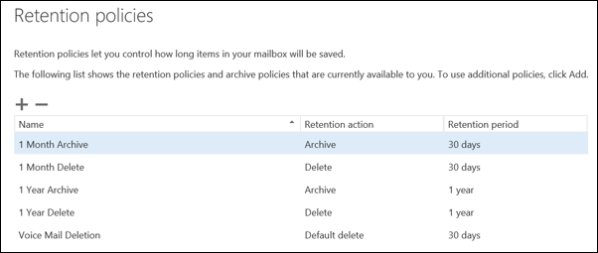

Here you will learn how to add archive and retention policies to your mailbox which will allow you to automatically archive or delete your mail.

1. To open your mail retention policies, log into myemail.accenture.com in Internet Explorer.



1. Select the Gear in the top-right corner and then select **Options**. You can also select **Mail** under **Your app settings**.



1. Then select **Retention** **policies** under **Automatic** Processing under **Mail.** To add a policy, select the **+** symbol.



1. Here you will be able to add or remove policies that are available to you. Select the policies you’d like to add and then select **Add** and then click **Save**.



1. You will now see the new polices in your list.



how to add archive and retention policies to your mailbox which will allow you to automatically archive or delete your mail.

1. To open your mail retention policies, log into myemail.accenture.com in Internet Explorer.



1. Select the Gear in the top-right corner and then select **Options**. You can also select **Mail** under **Your app settings**.



1. Then select **Retention** **policies** under **Automatic** Processing under **Mail.** To add a policy, select the **+** symbol.



1. Here you will be able to add or remove policies that are available to you. Select the policies you’d like to add and then select **Add** and then click **Save**.



1. You will now see the new polices in your list.



1. To open your mail retention policies, log into myemail.accenture.com in Internet Explorer.
2. Select the Gear in the top-right corner and then select **Options**. You can also select **Mail** under **Your app settings**.



1. Then select **Retention** **policies** under **Automatic** Processing under **Mail.** To add a policy, select the **+** symbol.



1. Here you will be able to add or remove policies that are available to you. Select the policies you’d like to add and then select **Add** and then click **Save**.



1. You will now see the new polices in your list.



Here you will learn how to add archive and retention policies to your mailbox which will allow you to automatically archive or delete your mail.

1. To open your mail retention policies, log into myemail.accenture.com in Internet Explorer.



1. Select the Gear in the top-right corner and then select **Options**. You can also select **Mail** under **Your app settings**.



1. Then select **Retention** **policies** under **Automatic** Processing under **Mail.** To add a policy, select the **+** symbol.



1. Here you will be able to add or remove policies that are available to you. Select the policies you’d like to add and then select **Add** and then click **Save**.



1. You will now see the new polices in your list.



how to add archive and retention policies to your mailbox which will allow you to automatically archive or delete your mail.

1. To open your mail retention policies, log into myemail.accenture.com in Internet Explorer.



1. Select the Gear in the top-right corner and then select **Options**. You can also select **Mail** under **Your app settings**.



1. Then select **Retention** **policies** under **Automatic** Processing under **Mail.** To add a policy, select the **+** symbol.



1. Here you will be able to add or remove policies that are available to you. Select the policies you’d like to add and then select **Add** and then click **Save**.



1. You will now see the new polices in your list.



Below are the steps how to add online archive and retention policies to your mailbox which will allow you to automatically archive or delete your mail.

1. To open your mail retention policies, log into myemail.accenture.com in Internet Explorer. For Shared mailbox log into [https://myemail.accenture.com/owa/<emailaddress>/](https://myemail.accenture.com/owa/%3cemailaddress%3e/).
2. Select the Gear in the top-right corner and then select Options. You can also select Mail under Your app settings.

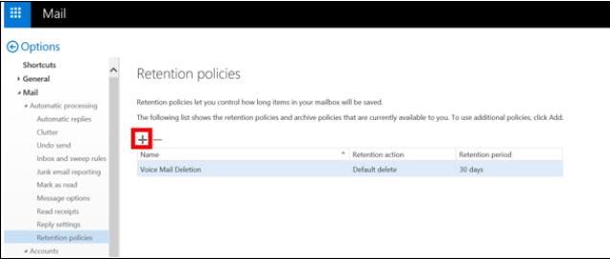

1. Then select Retention policies under Automatic Processing under Mail. To add a policy, select the + symbol.

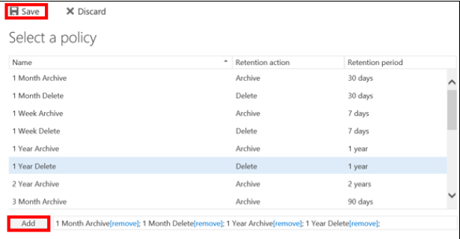

1. Here you will be able to add or remove policies that are available to you. Select the policies you’d like to add and then select Add and then click Save.

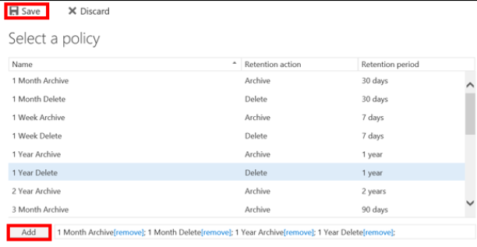

1. You will now see the new polices in your list.

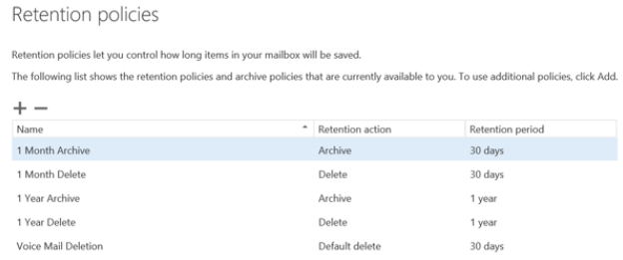



Note: Changes for online archive can take up to 24 hours for replication.

To assign a policy on a folder in Outlook:

1. In the left navigation pane, right click a folder and select Properties. (Note that it will take 1 day for policies to appear in Outlook after being added in OWA).

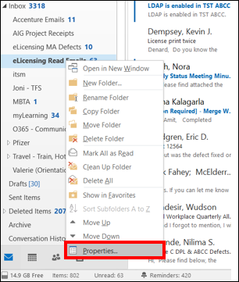

1. Select the Policy tab and then choose to select a Retention Policy or Archive Policy.
2. To assign a Retention Policy, select the retention policy you wish to apply in the drop down under Folder Policy and then select OK.

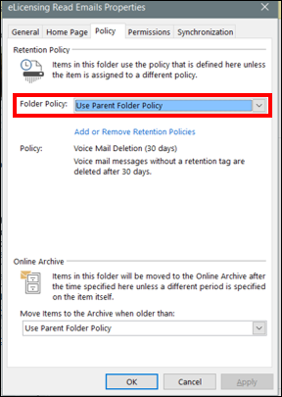

1. To assign an Archive Policy, select the archive policy you wish to apply in the drop down under Move items to the Archive when older than: and then select OK.

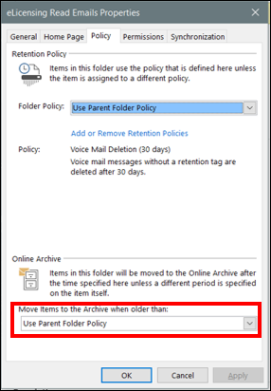

The selected option may take 24 hours to display on each item when selecting a folder. The applicable e-mails will not automatically move until the next time the Microsoft Exchange process runs (usually 1 time a day, but may take up to 48 hours).

1. If the mailbox is 25 GB full and user is not able to send and receive emails. SD can contact IAM team (**SNOW queue INFRADELV-IAM-IGA-OPER**) for temporary increase of mailbox quota.

**M&C DOES NOT PERFORM THE MAILBOX QUOTA UPGRADE**

**Assigning a policy on a folder**

To assign a policy on a folder in Outlook:

1. In the left navigation pane, right click a folder and select **Properties**. (Note that it will take 1 day for policies to appear in Outlook after being added in OWA).



1. Select the **Policy** tab and then choose to select a *Retention Policy* or *Archive Policy*.
   1. To assign a *Retention Policy,* select the retention policy you wish to apply in the drop down under **Folder Policy** and then select **OK**.



* 1. To assign an *Archive Policy,* select the archive policy you wish to apply in the drop down under **Move items to the Archive when older than:** and then select **OK**.



1. The selected option may take 24 hours to display on each item when selecting a folder. The applicable e-mails will not automatically move until the next time the Microsoft Exchange process runs (usually 1 time a day, but may take up to 48 hours).